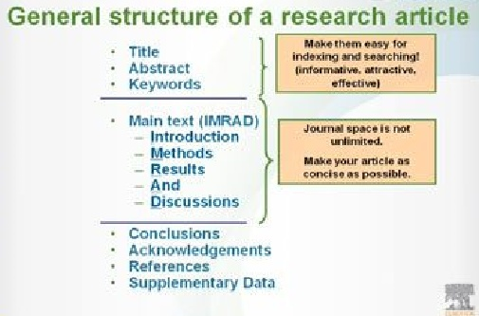

1. **Structure and Content of a Manuscript**

A manuscript is typically composed of a number of sections:

* Title and authors
* Abstract;
* Key words;

- Introduction;

- Method;

- Results;

- Discussion;

- Conclusions;

- Acknowledgement and

- References

1. Steps to organizing your manuscript
2. [Prepare the figures and tables](https://www.elsevier.com/connect/11-steps-to-structuring-a-science-paper-editors-will-take-seriously#step1).
3. [Write the **Methods**](https://www.elsevier.com/connect/11-steps-to-structuring-a-science-paper-editors-will-take-seriously#step2).
4. [Write up the Results](https://www.elsevier.com/connect/11-steps-to-structuring-a-science-paper-editors-will-take-seriously#step3).
5. [Write the Discussion](https://www.elsevier.com/connect/11-steps-to-structuring-a-science-paper-editors-will-take-seriously#step4).
6. [Write a clear **Conclusion**](https://www.elsevier.com/connect/11-steps-to-structuring-a-science-paper-editors-will-take-seriously#step5).
7. [Write a **compelling** introduction](https://www.elsevier.com/connect/11-steps-to-structuring-a-science-paper-editors-will-take-seriously#step6).
8. [Write the **Abstract**](https://www.elsevier.com/connect/11-steps-to-structuring-a-science-paper-editors-will-take-seriously#step7).
9. [Compose a concise and descriptive Title](https://www.elsevier.com/connect/11-steps-to-structuring-a-science-paper-editors-will-take-seriously#step8).
10. [Select Keywords for indexing.](https://www.elsevier.com/connect/11-steps-to-structuring-a-science-paper-editors-will-take-seriously#step9)
11. [Write the**Acknowledgements**.](https://www.elsevier.com/connect/11-steps-to-structuring-a-science-paper-editors-will-take-seriously#step10)
12. [Write up the**References.**](https://www.elsevier.com/connect/11-steps-to-structuring-a-science-paper-editors-will-take-seriously#step11)

**Chapter I : How to Write a Scientific Research Paper**

* Give the French and the Arabic translation to words in the table

|  |  |  |
| --- | --- | --- |
| **Anglais** | **Français** | **Arabe** |
| **Title** |  |  |
| **Abstract** |  |  |
| **Keywords** |  |  |
| **Main text** |  |  |
| **Acknowledgements** |  |  |
| **Data** |  |  |
| **Indexing** |  |  |
| **References** |  |  |
| **Introduction** |  |  |
| **Background** |  |  |
| **Topic** |  |  |
| **Outline** |  |  |
| **Method of sampling** |  |  |
| **withdrawal** |  |  |
| **Explanations** |  |  |
| **Recommendations** |  |  |
| **further research** |  |  |
| **brief statement** |  |  |
| **implications** |  |  |
| **Conclusion** |  |  |
| **Scientific experiments** |  |  |
| **Impact** |  |  |
| **communication** |  |  |
| **research paper** |  |  |
| **Concisely** |  |  |
| **Readers** |  |  |
| **Authors** |  |  |
| **guideline** |  |  |
| **Provides** |  |  |
| **Allow** |  |  |
| **Similar** |  |  |
| **well-structured** |  |  |
| **manuscript** |  |  |
| **publication submission.** |  |  |
| **Process** |  |  |
| **required** |  |  |
| **The target** |  |  |
| **Accuracy** |  |  |
| **Combine** |  |  |
| **The main** |  |  |
| **several attempts** |  |  |
| **the topic** |  |  |
| **Summarize** |  |  |
| **Purpose** |  |  |